**Task 2- Crime Data Analysis**

7.

from pyspark.sql.functions import year, to_timestamp, to_date, col

# Convert 'REPORTDATETIME' to timestamp format

data = data.withColumn("Date", to_date(col("REPORTDATETIME"), "MM-dd-yyyy").alias("to_date"))

# Extract the year from 'DATE'

data = data.withColumn("Year", year("Date"))

# Filter records for the year 2013

offenses_2013 = data.filter(data["Year"] == 2013)

# Count the number of offenses in 2013

num_offenses_2013 = offenses_2013.count()

# Print the result

print(f"Number of offenses in 2013: {num_offenses_2013}")

8.

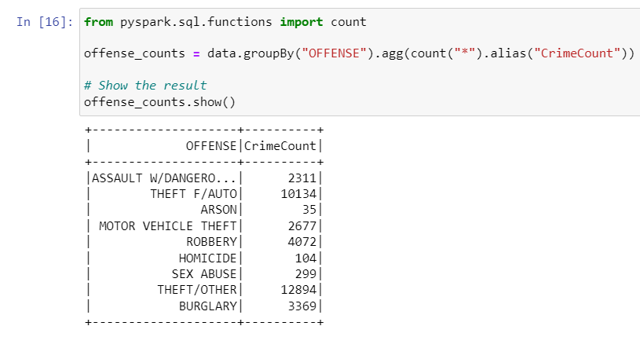

9.

10.

